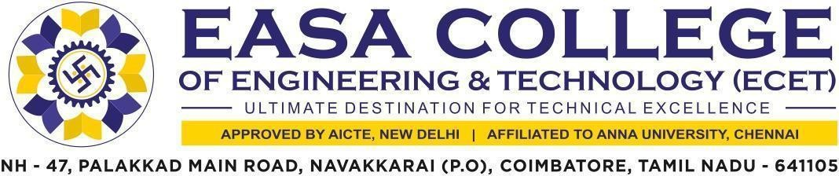
    - Quality audits on environment and energy regularly undertaken by the Institution. The institutional environment and energy initiatives are confirmed through the following
      - Green audit / Environment audit
      - Energy audit
      - Clean and green campus initiatives
      - Beyond the campus environmental promotion activities

The supporting documents for this metric exceed the upload limit of 5Mb. Hence the documents are made available in HEI website and links for the metric is given below.

Metric | Parameter | Link to Relevant Document
7.1.3 | - Quality audits on environment and energy regularly undertaken by the Institution. The institutional environment and energy initiatives are confirmed through the following  - Green audit / Environment audit  - Energy audit  - Clean and green campus initiatives  - Beyond the campus environmental promotion activities | VIEW

